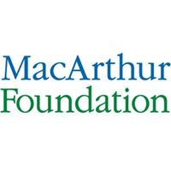


A Report of

3-Day Capacity Building Workshop on
Christianity and Corruption
North-Central Zone
(MOCAC 2.0)

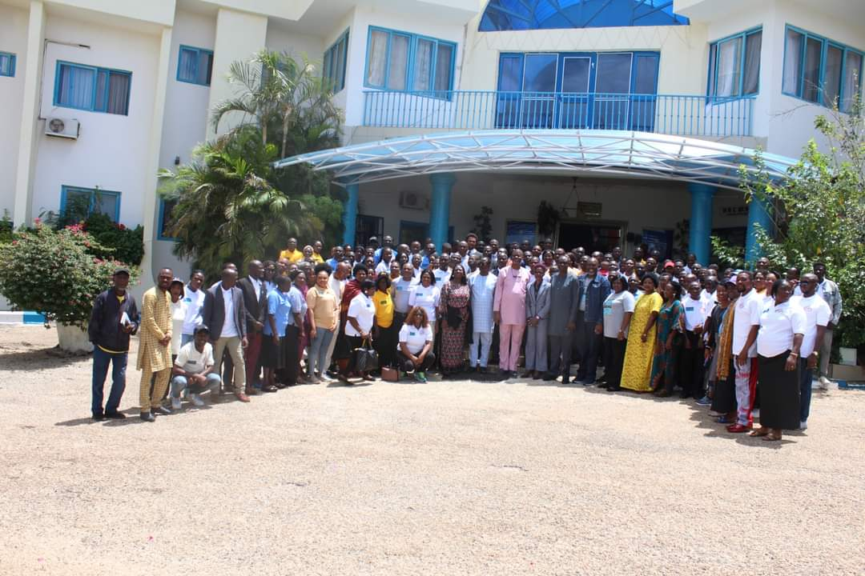

Organised by
Priests Peace and Justice Initiative (PPJ)
With the Support of MacArthur Foundation

Held at
HBC Resort, Jos
June 13 - 15, 2023

Prepared by:
Clement Ekeoba, Clape Consulting, Abuja
Table of Contents
List of Pictures 2
1.0 Preamble 3
2.0 Day One: June 13th, 2023 4
2.1 Opening Session 4
2.2 Welcome Address by General Overseer, PPA/Programme Director, PPJ 4
2.3 Goodwill Messages 5
2.4 Introduction of the Shun Corruption Project 7
2.5 Administration of Pre-Test Evaluation Questionnaire 9
2.6 Technical Sessions 9
2.6.1 Module One: Christianity and Social Dimension of the Church 9
2.6.2 Module Two (2): The Science and Art of Training 12
2.6.3 Module Three (3): Drivers of Corruption Within and Outside the Church 14
2.7 Closing for Day One 15
3.0 Day Two: June 14th, 2023 15
3.1 Technical Sessions 16
3.1.1 Module Four (4): Understanding Gender Equality and Social Inclusion (GESI) in Project Implementation 16
3.1.2 Module Five (5): Christianity and the Struggle for Social Justice 18
3.1.3 Module Six (6): Christianity and Accountability 21
3.2 Closing for Day Two 23
4.0 Day Three: June 15th, 2023 23
4.1 Technical Sessions 23
4.1.1 Module Seven (7): Christianity and Leadership 23
4.1.2 Module Eight (8): Christianity and Fight against Corruption 24
4.1.3 Module Nine (9): Investment and Income Generation 26
4.2 Next Steps, Expected Outcomes and Feedback Mechanism 33
4.3 Closing Session 34
4.3.1 Administration of Post Test and Workshop Evaluation Questionnaires 34
4.3.2 Closing Remarks and Prayer 35

List of Pictures
Pic 1: Mrs: Gloria Ejembi leading praise and worship session ………………………………………………………………….4
Pic 2: Pst (Dr) Otive Igbuzor presenting his welcome address 4
Pic 3: Pst (Mrs) Esther Dogonyaro 6
Pic 4: Dr. O. Agbaji, PM, PPJ Introducing the project to participant 8
Pic 5: Pst (Dr) Otive Igbuzor facilitatiing question and answer 10
Pic 6: Dr (Mrs) Ehiro Igbuzor facilitating the science and art of training 12
Pic 7: Dr (Mrs) Ejiro Igbuzor facilitating Gender Equality Social Inclusion 16
Pic 8: Pst (Mrs) Esther Dogonyaro facilitating christian and the struggle on social justice 18
Pic 9: A cross section of participants listening to christianity and the struggle on social justice 19
Pic 10: A cross section of participants listening to christianity and fight against corruption 24

1.0 Preamble
Priests Peace and Justice Initiative (PPJ) is the social arm of Palace of Priests Assembly (PPA), a notable Pentecostal Christian mission in Nigeria. The initiative was conceived to promote the building of a peaceful, just and orderly society, and uphold the dignity of the human person as created by God. As a Faith-Based Organization (FBO), it is the duty of PPJ to bring biblical perspective to the challenges of democracy, development, insecurity, injustice, service delivery and humanitarian crisis. The vision of PPJ is: ‘a world of prosperity and social justice’ while its mission is: ‘to act as catalysts to empower citizens to reign as Priests and work for peace and social justice’. Guided by the values of leadership, empowerment, royalty, integrity and discipleship, PPJ has the following five areas as its thematic focus:

- Democracy: Elections, transparency and accountability and stewardship.
- Peace Building: Human Security and Conflict transformation.
- Social Justice: Poverty, Inequality and Justice.
- Emergency and Humanitarian services.
- Education and Health.

The 3-Day Capacity Building Workshop on Christianity and Corruption is a train the trainers programme convened by PPJ with support from MacArthur Foundation as part of the second phase of the SHUN Corruption project also known as Mobilising Christians Against Corruption (MOCAC 2.0). The project’s overarching goal is to promote zero tolerance for corruption among Pentecostal Christians through adherence to positive group norms, peer-to-peer accountability, and institutionalization of platforms against corruption. The workshop was designed to draw from the research conducted in phases one and two of the project. It focused on the social dimension of the church, social justice, and the fight against corruption. In addition, it was targeted to build the capacity of the Pentecostal leaders to actively participate in the campaign to promote accountability and integrity in Nigeria including issues relating to voice and agency of citizens.

The capacity building workshop was held serially in different regions of Nigeria including the North (Abuja); South West (Lagos) and South-South/South-East (Port Harcourt). The one held in Jos between June 13 and 15, 2023 was the fourth in the series.

2.0 Day One: June 13, 2023
The following were the various sessions/activities at the workshop on the first day – June 13, 2022:

2.1 Opening Session
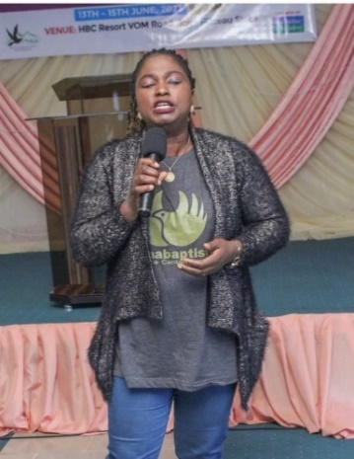
The 3-Day Capacity Building Workshop was held at HBC Resort, Jos between June 13 and 15, 2023. The programme started at exactly 9:45am on the first day with an opening prayer which was said by a participant and praise session led by Mrs. Gloria Ejembi. The workshop had about a hundred participants in attendance on the first day drawn from the Pentecostal Christian community within Plateaus State and other neighbouring States and the media.
Pic 1: Mrs G. Ejembi leading praise at the opening session

2.2 Welcome Address by General Overseer, PPA/Programme Director, PPJ
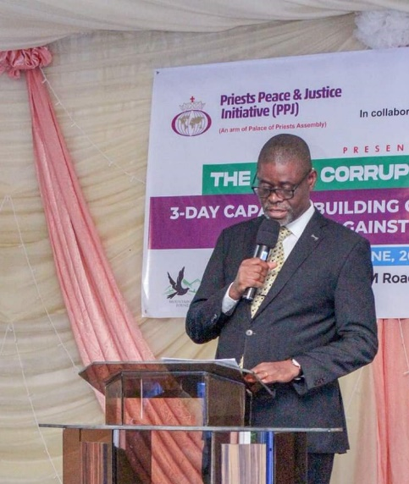
The General Overseer of PPA who doubles as the Programme Director, PPJ - Pst (Dr.) Otive Igbuzor appreciated participants for honoring the invitation to the capacity building workshop. He acknowledged dignitaries present. He started his welcome address by saying fight against corruption is very dear to him because corruption is a huge problem. He highlighted the problems of corruption in Nigeria and described it as deep, systemic and widespread despite the different efforts by government since independence to address the menace. The programme Director said it was unfortunate that for many years Nigeria has been repeatedly rated low by Transparency International in its annual global corruption index. Furthermore, he pointed out that PPA through its social arm – PPJ was motivated to develop the SHUN Corruption project some years ago as it was apparent that Pentecostal Christian leaders were not effectively engaged in the fight against corruption in Nigeria. The project which is in its second phase according to the Pst (Dr.) O tive Igbuzor, is supported by the John D. and Catherine T. MacArthur Foundation as part of its Big Bet On Nigeria Anti-Corruption programme. He added that the first phase was implemented between January 2018 and April 2021. Some of the notable achievements of the first phase of the project was said to include:
Pic 2: Pst Otive Igbuzor welcoming participants to the workshop
- The establishment of structures and platforms to fight corruption;
- The building of a critical mass of advocates to generate a ripple effect in the fight against corruption;
- Documentation of several scriptures against corruption; the creation of platforms against corruption across several strata of the society among others.

In the second phase, the Programme Director explained that the focus of the project will be on grounding corruption norms and practices and elevating the motivation to bring about change in individual and group behaviour. This, he said, is being done through the establishment of social arms in Churches to address social issues and fight corruption. In addition, he explained that individuals who use the 3S model of: SHUN corruption, STAND UP against corruption and SPEAK OUT against corruption will be recognised and celebrated.

He further stated that Pentecostal Christian leaders have not been effectively engaged in the fight against corruption which will help to strengthen accountability, transparency in Pentecostal setting in Nigeria. He added that participants would be expected to step down the knowledge gained from the workshop in their respective churches and various organizations as the workshop was designed to adopt the train the trainer approach. While closing his address, Pst (Dr.) Igbuzor encouraged participants to be attentive and be opened to learn. In closing, the general overseer expressed gratitude to the Pentecostal Fellowship of Nigeria (PFN) for their support and stated that through the project, ninety-one churches have so far established their social arms with structures and management teams put in place.

2.3 Goodwill Messages
The goodwill messages were delivered by PFN National Vice-President as well as other leaders of PFN in the north.

The PFN National Vice-President - Prophet (Dr) Isa El Buba, called on Christians to endeavour to make impact in the life of people around them and added that in dealing with the issue of corruption, upright leadership is key because it influences the way people live and what they do. He stated that leadership is an art of giving guidance to a group of people, an organization or community. The church of Jesus Christ which is a pillar of hope that the world is looking u to is to have leadership that will stand as men and women of principles. Leadership throughout history has been one of the greatest things, that has led nations to build institutions that sustain communities and societies at large. According to him, one of the greatest leaders ever is Jesus Christ who lived a life worthy of emulation promoting justice, light and transparency.

The PFN Chairman (Plateau State Chapter) in person of Rev. (Dr). Stephen Dangana, appreciated the Palace of Priest Assembly and acknowledged Dr. Otive Igbuzor for his determination in pursuing a worth course of fighting corruption in the society. He stated that corruption is one of the most notorious vices eating up our beloved country and other countries at large and cited Dr. Ngozi Okonjo-Iwela’s conclusion that “If you fight Corruption, Corruption will fight you back” just to show how corruption is rooted in our present society.
The PFN Chairman (Gombe State Chapter) Rev. Lekai Yusuf, laid emphasis on molding the youth in the right direction, owing to the fact that youths are the future of tomorrow. He explained that if they are groomed in a just and incorruptible way, it will help them to resist and fighting corruption of all kinds within the church and society

The PFN Chairman (Bauchi State Chapter) Rev. Promise Yohanna expressed his profound appreciation to PPJ for the opportunity to be part of this awesome course. He highlighted the importance of the workshop organized by PPJ and how it has impacted his church as he was part of the workshop last year. He informed the audience that his church established a social arm in Bauchi called ‘Life Savers Initiative’ which has reached out to a lot of beneficiaries and has been encouraging churches within their locality to set up a social arm. He added that they were engaged in election monitoring in Bauchi state as a result of the relationship with PPJ.

The PFN Chairman Benue state chapter represented by Arch-Bishop Okorie sent his warm greetings and expressed joy in attending the programme. He added that he came with an open heart to learn from the training and he promised to step it down to pastors in Benue.
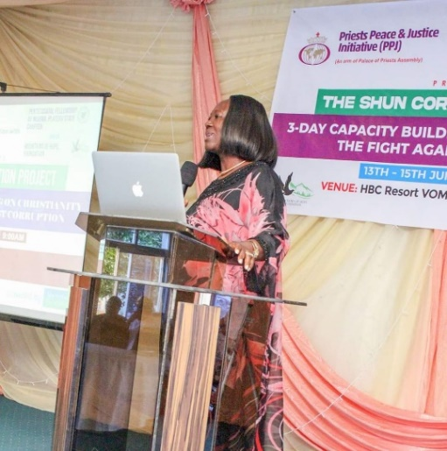
The President of Mountain of Hope Foundation, Pastor (Mrs.) Esther Dogonyaro said Palace of Priest and Justice (PPJ) is a leading voice in ensuring transparency and building a people of integrity in each sectors of the society aimed at resolving problem associated with bad governance, through leadership development intervention programmes. She informed participants that with Dr Otive Igbuzor’s guidance, Mountain of Hope Foundation collaborated with Africa Centre for Leaders, Strategy and Development in Abuja to establish a leadership school in Plateau State. She expressed optimism that the 3-day training will equip Christian leaders with the necessary knowledge and tools to promote transparency, accountability and ethical conduct within their respective congregations. She urged pastors to align with the original plan of God for mankind according to His words as any deviation from it, is corruption.
Pic 3: Pst E. Dogonyaro delivering her goodwill message at the workshop

2.4 Introduction of the Shun Corruption Project
The Programme Manager (PM) – Dr. Orinya Agbaji facilitated a session on the introduction of the SHUN Corruption project. The presentation touched on the following outline:
- Introduction of the Project
- Project Goal and Objectives
- Summary of Year 1 Activities and Programmes
- Summary of Year 2 and 3 Activities and Programmes
- Summary of Year 1 t0 3 Activities and Programs
- Project Activities of MOCAC 2.0
- Conclusion – Lessons Learnt and Challenges

The PM explained that the overall objective of the project is to reduce corruption by supporting Nigeria government lead effort to strengthens accountability, transparency and participation among Pentecostal Christians through adherence to positive group norms, peer-to-peer accountability, and institutionalization of platforms against corruption. He stated that 91 churches have established their social arms. He urged church leaders to embrace the dual mandate stressing that the church is expected to minister to the spiritual and the physical needs of the people. The specific objectives were identified as follows:
- To promote the establishment of the social arm of the church as an instrument for fighting corruption and adopting accountability framework for Pentecostal churches.
- To enhance the capacity and capability of the Pentecostal Community in Nigeria to adopt social arm of the church and accountability framework within the church and champion the fight against corruption outside the Church (in communities, towns, unions, workplaces, academic institutions, marketplaces, etc.).
- To enhance ‘voice’ and ‘agency’ of Pentecostal leaders and workers as active citizens performing their civic duties, participating in politics, elections, and governance in Nigeria.
- To activate Pentecostal campaign platforms visibly taking collective action against corruption.
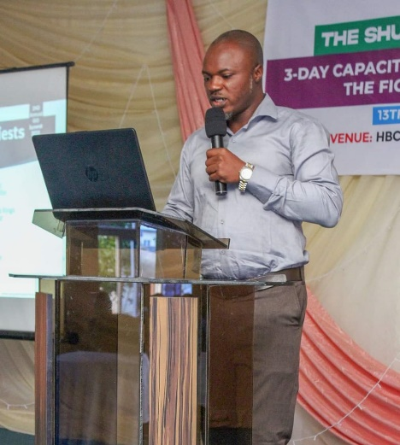
- To promote behavior, change among Pentecostal Churches regarding accountability within and outside the church.

The activities and programmes of the first phase were highlighted to include building structures/platforms & partnership to implement the project as well as building a critical mass of key trainer, advocates & campaigners to generate the ripple effect needed to replicate results at all levels. A research on 5 key themes was also commissioned. In the second and third year of the first phase, the project activities and programmes were framed around the following 5 outcomes:
Pic 4: Dr O. Agbaji, PM, PPJ introducing the project to participants

- Outcome 1 – Established interdenominational planforms actively mobilizing their constituencies against corruption
- Outcome 2 – Enhanced knowledge of the Scriptural basis for Christians' participation in the fight against corruption
- Outcome 3 – Increased engagement of Christian Leaders on anti-corruption activities
- Outcome 4 – Established platforms' increased participation in politics, electioneering and governance
- Outcome 5 - Elevated voices of young Pentecostals against corruption in workplaces, professional groups, students' organizations, etc.

The outcomes from the first phase of the programme were summarised as follows:
- The beneficiaries now understand what constitutes corruption and are equipped to shun, speak against and stand against corruption.
- Many of the beneficiaries have shown great signs of shunning and speaking up against corruption; some have demonstrated great ability to standup against corruption.
- Using the trans theoretical behaviour change framework as a benchmark, PPA/PPJ have evidence that beneficiaries have evolved:
  - From being 'in denial' about the existence and consequences of corruption;
  - To changing mindsets, becoming aware and having knowledge of the potential benefits of making a change.
  - By the end of Years 1 & 2, the ability of many Pentecostals across sex, age-groups, professions and locations had been built to Shun, Speak-out and Stand (take action) against corruption
  - By Year 3 outreaches had fully evolved towards targeting the group environment/field as the centre of change – strengthening, multiplying the number, type and membership of campaign platforms; building traction on the need to uphold transparency and accountability.

Furthermore, Dr Agbaji said that 27 WhatsApp groups have been set up so far while about 91 Churches have set up their own social arm. By way of conclusion, he emphasised that as incentive for behaviour change, Christians who activate the 3‘S’ model of Shunning, Standing and Speaking against corruption will be celebrated to encourage others to follow suit.

2.5 Administration of Pre-Test Evaluation Questionnaire
A pre-test evaluation questionnaire was administered to participants, by the PM Dr. Orinya to facilitate the collection of baseline information to ascertain the knowledge level of participants on the subject of the capacity building on Christianity programme.

2.6 Technical Sessions
The following were the modules participants were taken through on the first day of the programme:

2.6.1 Module One: Christianity and Social Dimension of the Church
The first technical presentation at the workshop was on Christianity and Social Dimension of the Church. The presenter Pst (Dr.) Otive Igbuzor who is the General Overseer, PPA gave the objectives of the module as below:

- To outline the history of the Church and neglect of the social dimension of the Church,
- To underscore the importance of the social dimension of the Church,
- To outline how a local Church can establish and operationalise the social arm,
- To indicate the role of PFN in operationalising the social arm of the Church,
- To indicate the role of PPJ in operationalising the social arm of the Church

The outline of the presentation was made up of the following:
- Introduction
- History of the Church
- Rise of Pentecostalism and neglect of the social dimension
- Challenge of the Neglect for Society
- Lesson from the First Church - Catholic Church
- How a local Church can Establish the social arm
- Programmatic Focus of the social arm of the Church
- The role of PFN in operationalising the social of the Church
- The role of PPJ in operationalising the social arm of the Church
- Conclusion
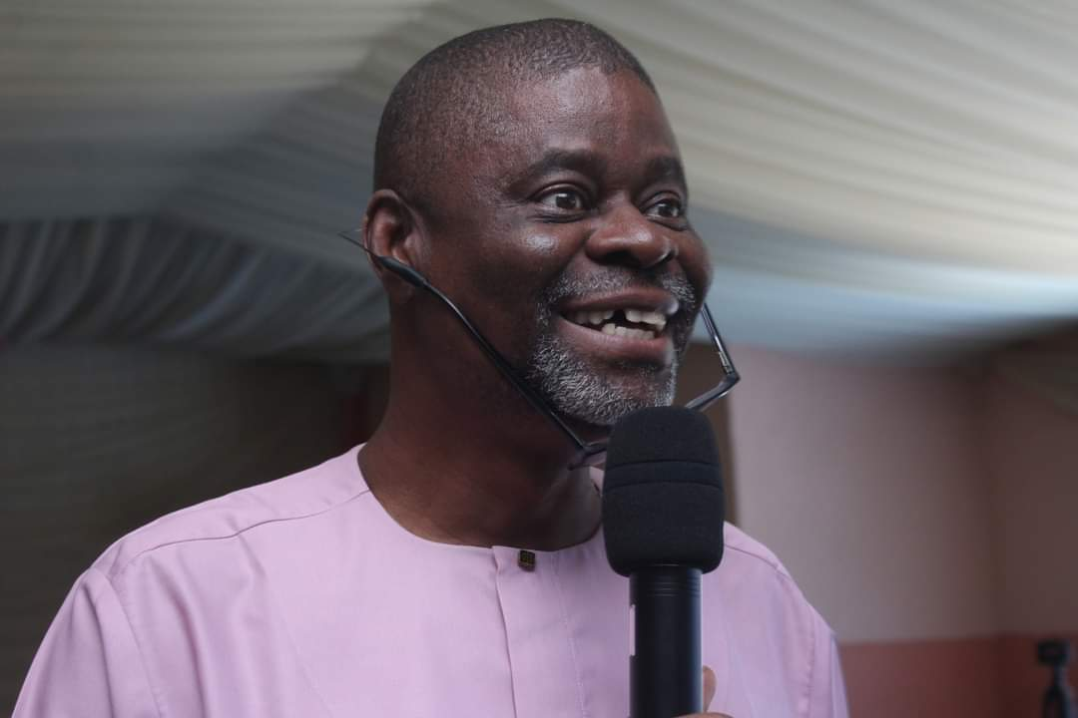
In course of the presentation, Pst. (Dr.) Igbuzor pointed out that the church has a ‘Dual Mandate” (Spiritual Dimension and Social Dimension) which was reflected in the practical ministry of Jesus Christ (Luke 4:18). He explained that the early church at some point was fused with the government, however, there have been dynamic transformations in the church over the centuries such that in the first 300 years, persecution and martyrdom increased and subsequently the fusion between the church and the State. He traced the history of Pentecostalism to the several reforms and revivals in the development of the church over the years and observed that it came with a rise in individualism and a neglect of social dimension of the church. The facilitator explained that the Catholic church seems to place emphasis on social dimension through what they call the Social Teachings of the Catholic Church. Consequently, Catholic churches have social arms and foundations like the JDPC, CRS, etc.
Pic 5: Pst (Dr) Otive Igbuzor facilitating a question and answer segment at the workshop

The PPA General Overseer recommended the following as critical steps a local Church should follow to establish and operationalise the social arm:
- Identify believers in the church who have experience on social issues advocacy.
- Form a team to establish the social arm: get a name and a management team.
- The church’s registration can serve for the social arm or it can be registered separately.
- Prepare the background material and start operations.

The role of PFN in operationalizing the social dimension of the Church were stated in the presentation as follows:

- Accept, popularise and give priority to the dual mandate;
- Institutionalise social arm of the church as a core practice in Pentecostal movement;
- Encourage, support and motivate members to establish social arm in their various churches,
- Advocate for institutionalisation of the social arm of the church for Pentecostal churches;
- Give technical support to churches who want to establish the social arm of their church;
- Build capacity of Pentecostal churches to operate their social arms especially in terms of formation and management.

Questions and Responses
The following were questions asked by participants after the presentation:
- What is the bible dimension on social arm?
- How do you balance Christianity and politics taking a clue from the history of the church?
- What would be the size of the church before you give technical support?
- It will not be the issue of the Roman Catholic teaching us how to run social dimension, what other ways can we learn and run with this new truth?
Responses:
- Read Luke chapter 4 vs 18 to gain understanding of the social arm of the church
- Moderation is key, be focused on politics according to the scriptures just as Jesus has instructed us
- The church has to be growing to be able to take care of its operations. It is an error to establish a social arm and stop because of funding. You could identify believers in your church who have experience on social arm.
- Learn from people who have gone ahead of you and are successful in doing what you want to do whether they are Catholics or not.

2.6.2 Module Two: The Science and Art of Training
This module on: The Science and Arts of Training was presented by Pst. Dr. Ejiro Ogbuzor who joined the workshop virtually. The training objective according to her is to enhance participants’ knowledge and skills in organizing and facilitating trainings. Key issues outlined by the PPA’s Assistant General Overseer in her presentation include:
- Basic Principles of Adult Learning
- Training cycle - Needs Assessment, Objectives, Planning/Design, Implementation, and Monitoring and Evaluation
- Facilitation and Basic Facilitation Skills
- Learning theory
- Tips about brains including retention and recall
- Differences between teaching and training

She also noted some salient points every trainer is expected to know and urged participants to approach the entire workshop with an open mind so as to be able to learn. The presenter emphasized three core elements the training seeks to address. They are: (a) Knowledge, (b) Skills (c) Attitudes, otherwise known as (KSA or ASK). The terms were defined as follows:
- Knowledge: Retaining facts and information
- Skills: Aptitude, the ability to do something
- Attitude: Expressing feelings and values in a given situation; showing emotions

The facilitator defined training as “the process that involves the acquisition of knowledge, sharpening of skills, concepts, or changing of attitudes and behaviors to enhance performance”. She further explained that a facilitator is different from a trainer. A facilitator enhances your learning, make other people understand better the content of the discourse and freewill to make their input. Dr Ejiro explained that trainings are more effective when there are clear results or goals set out to be achieved. She also highlighted the 4 laws of training to include:

- Knowing what is to be taught;
- Training from a prepared lesson plan;
- Create a motivational environment; and
- Use of understandable language

The five stages of a training circle were identified to include:
  - Needs assessment
  - Goal/objective
  - Planning and design
  - Implementation
  - Monitoring and evaluation
The four skills of a facilitator are as follows;
- Attending Skills
- Observing Skills
- Listening Skills
- Questioning Skills
In addition, Pst. (Dr). Ejiro explained that brains do not decline as long as they are constantly stimulated but it goes into auto-shut after only 10 minutes if it is not given something to stimulate it. The brain has the capacity to retain and recall information, but the number of times the message is presented determine the percentage of retention. She added that “mindset is an enemy of recall” In conclusion, the facilitator highlighted several ways to handle difficult situations in course of a training. Notable among them are:
- For outbursts – Be positive, smile, encourage, nod, use lubricators; Listen actively
- To challenger – Don’t be upset, find merit, throwback misconception to group for correction.
- For those who talk and want to show that they know all – Wait for them to finish, thank, refocus, move on; Slow them down with a tough question; Jump in and ask the group to comment

Question and Answer
- How do you facilitate the know it all student?

Answer
- Wait for the person to finish, thank, refocus, move on; Slow them down with a tough question; Jump in and ask the group to comment.
- You can also use psychological judo.

2.6.3 Module Three: Drivers of Corruption Within and Outside the Church
This module was facilitated by Prof. Ismael Ogboru. He gave the outline of the presentation as follows:
- Purpose of the Presentation
- Understanding Drivers of Corruption Within and Outside the Church,
- Efforts of Pentecostal Churches to tackle Corruption within and Outside the Church,
- Building the Capacity of Pentecostal Churches to identify and confront Drivers of Corruption within and outside the Church
- Summary

The purpose of the presentation was given by the module facilitator as follows:
- To deepen participants’ understanding of drivers of corruption within and outside the Church, and how these drivers have caused corruption to thrive within and outside the Church
- To increase participants awareness of effective ways of tackling drivers of corruption within and outside the church.
- To appraise the efficacy of ongoing efforts at preventing corruption within and outside the Church

The major drivers of corruption were identified by the facilitator as below:

- The drivers of corruption as identified include, greed and indiscipline, selfishness and self-centeredness, conceived by man.
- Unhealthy competition among leaders and laity, which is driving the issue of corruption in our present churches and society
- Pressure to meet societal expectations with deficit legitimate means,
- The emphasis on material possessions and prosperity and materialistic definition of success.
- The entitlement perception, it’s my turn, and I must succeed by all cost, including materialistic success.
- The sizes of auditoriums and make of cars are taken as signs of success for many General Overseers.

In addition, drivers of corruption outside the church were identified as follows:
- Normalization of corruption in society -- “a new normal” is emerging when corruption is seen as normal,
- Pressure to meet societal expectations with deficit legitimate means,
- Erosion of noble social norms of integrity and probity,
- Greed and Indiscipline

Prof. Ismael Ogboru examined efforts made to reduce corruption both within and outside the church and recommended the following to curtail corruption in the Church:

- Put systems in place. Records to check people. Once found wanting they can be relieved of their jobs.
- Use Forms for Requesting Funds (FRFs) Requisition forms will help. After funds are spent, the person concerned should come with receipts to verify purchases. Don’t give people money that they can’t handle.
- Give responsibilities to people with relevant capacities.
- Adequate remuneration for workers.
The facilitator concluded by observing that it is unfortunate that people get themselves involved in all manners of corrupt practices. As Christians, we should shun, speak and stand against corruption anywhere and anytime.

2.7 Closing for Day One
Day one sessions and activities came to an end at exactly 3:55pm with a prayer said by a volunteer participant.

3.0 Day Two: June 14, 2023
The activities for day two commenced with opening prayer and praise session led by Pst Wealth Ukegbu. This was followed by a recap of day one’s activities facilitated by Dr. Orinya Agbaji, Programme Manager, PPJ. Participants recalled what they learnt the previous day as follows:

- Gender equality breaks barrier like culture, tradition and other things.
- Corruption can be scripturally defined.
- There is imbalance in many ministries between spiritual and social arm.
- Corruption is sin and sin is corruption.
- If the church come together, it can clean up the nation.

Participants were appreciated by the PM who also encouraged them to stay focused and attentive during the day’s sessions. Attendance of participants at the programme improved significantly on the second day.

3.1 Technical Sessions
The following were the activities held during the technical sessions on the second day of the programme:

3.1.1 Module Four: Understanding Gender Equality and Social Inclusion (GESI) in Project Implementation
Pst. (Dr.) Ejiro Otive-Igbuzor – Assistant General Overseer, PPA facilitated the module on Understanding GESI online. She explained that the concept of GESI is broader and more inclusive and noted that gender considerations begin from programming and planning. She drew the attention of participants to the fact that corruption tends to affect women and girls differently as they have been left behind so much even in Christendom but the Pentecostal church was the first to open up the space for women to come into the pulpit. In spite of this, she noted that the gap was still wide. The presentation had the following outline:

- Sex versus Gender
- GESI Knowledge and Awareness
- Acknowledgement of the Diversity of Creation
- Gender Equity versus Gender Equality
- The Concept of GESI
- GBV – Is it happening in your Church?

- Is the Bible against Equality?
- GESI in Project Design

Citing Genesis 5:2, the facilitator explained that sex is a product of nature as God created human as male and female while on the contrary gender is nurtured and a product of the society. She described gender equity as being fair to women and men according to their respective needs by ensuring that they have the support needed to access, participate and achieve their full potentials. On the contrary, she conceptualised gender equality in terms of outcomes explaining that equal treatment does not necessarily result in equality of outcomes. The Assistant General Overseer explained that equality has to do with removal of barriers rather than providing support or aid to people in form of like quota, subsidies, capacity building, etc. To Proclaim the reality of gender gap she made reference to the ratio of female to male in the Nigerian Senate as just 8 females to 101 males while the House of Representatives is 12 females to 348 males. Equally disturbing is the fact that fifteen states in Nigeria do not have a single female in their legislative houses. Furthermore, some concepts associated with GESI were explained by the facilitator as follows:
- GESI – an approach that seeks to address unequal power relations experienced by people on the grounds of gender, wealth, ability, location, race, caste/ethnicity, language and agency or a combination of these dimensions.
- Agency – the capacity of women and girls as well as other marginalized groups to take purposeful action and pursue goals free from the threat of violence and retribution. Having agency means having the capacity to act independently and to make own choice or take decisions for yourself.
- Social Exclusion - A process that renders marginalized women, men and persons intersex, and various categories unable to participate fully in economic, social, political and cultural life.
- Social Inclusion - Seeks to address inequality and factors to make it difficult for some categories of persons to participate in the political, economic and environmental life of one’s country and the world at large.
She explained that gender is belief, expectations, customs and practices within a society that defined masculism and feminine attribute. She went further to note that women have always been suppressed, and that God doesn’t discriminate and urge participant to stand up for injustice and discrimination.

Pst. Dr. Ejiro Igbuzor called on Christian leaders to recognize the different groups in the church and find ways to transform those seen as dysfunctional within the context of Christian service rather than casting them out. She added that while Jesus Christ was on earth, as recorded in the Bible, He reached out to all kinds of persons, widows, orphans, the poor, children, persons with disability, the adulterer, etc. In closing, she pointed out that discrimination plays out in two ways in the society - Direct Discrimination which includes less favourable treatment of a person compared to another person due to a personal characteristic for example girl-child marriage. The other one is Indirect Discrimination which involves the use of an apparently neutral practice, provision or criterion which puts people with a particular characteristic at a disadvantage compared with someone without that characteristic like failing to capture the needs of persons with disability when creating access path to a building. All these according to the facilitator can be addressed in the course of programming by:
- Problem identification,
- Project design,
- Project implementation,
- Project monitoring and evaluation.

Questions and Responses
Questions:
1. Why do women use the concept of equality to oppress the men?
2. Why can’t God call women to be priest, should women not compete with men?
3. Why are so many leaders living a double standard life?
4 Why are churches refusing to wed same sex marriage?
Responses by Dr Otive Igbuzor
1. How many men have been abused by women? The percentage is almost insignificant compared to the number of women abused by men. He went further to ask men to indicate by the raise of their hands if their wives abuse them.
2. He told them the story of Deborah in the bible - Judges chapter 4
3. That is why we are giving this training on the fight against corruption; we would take this truth to the end of the world and income generation training would be given to participants to further strengthen their capacity to create wealth and source of livelihood
4. First off, it is a crime in Nigeria and also don’t join them, just recognize them and pray for them - be clear about your standard.

3.1.2 Module Five: Christianity and the Struggle for Social Justice
The module on Christianity and the Struggle for Social Justice was facilitated by Pst. (Mrs.) Esther Dogonyaro. She reflected on the word of God in the book of Jeremiah 9: 23 – 24 which clearly shows that God is a God of social Justice. The objectives of the module were as follows:

- To introduce participants to the concept of the struggle for social justice,
- To explore God’s care for social justice and the Christian heritage of fight for justice,
- To examine the role of the church in the struggle for social justice.

She gave the outline of the module to include the following:
- Introduction
- Why Should a Christian Care about Justice? Does God really Care about Justice?
- God and Justice
- The Christian Heritage of Fighting for Justice
- The Closing of the Christian Mind
- In Nigeria today the Christian voice is not loud and clear
- What can be done
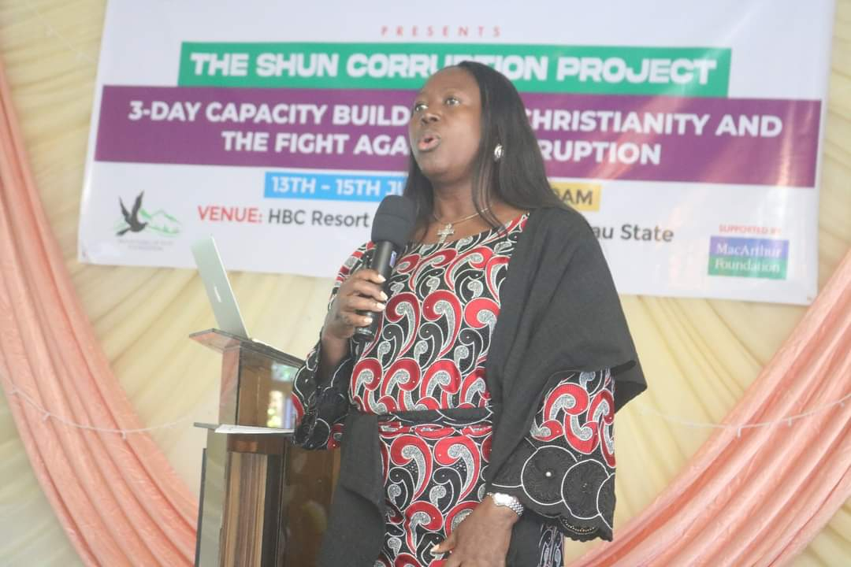
Pst Esther pointed out two things that matters with regards to social justice which are - God and Government and noted that both want the best of life for human beings. She defined social justice as a fair and just relationship between the individual and society measured by the distribution of wealth, opportunities for personal activity and social privileges. The following were identified as common elements in conceptualizing social justice which are abound in contemporary theories:
Pic 6: Pst (Mrs): Esther Dogonyaro facilitating Christianity and the struggle for social justice
- The duty of the state to distribute certain vital means,
- The protection of human dignity,
- The affirmative actions to promote equal opportunities for everybody – this is means giving to people to bring them to some acceptable level of humanity.

The facilitator stated that, if the state is not doing what it ought to do, believers are meant to speak up. She explained that there is a spiritual perspective to social Justice. Turning of water into wine is social justice, she stressed that we must first ensure equity before we can enjoy equality. Historically, Pst. (Mrs.) Dogonyaro made reference to some religious bodies that practice Social Justice which include; Islam, Judaism, Methodism and Catholicism. Other highlights of the session were as follows:
- The message of peace and justice is so central to the message of salvation in Christ Jesus that we cannot be blackmailed to abandon the work of justice and peace because God is a God of justice.
- Because God is sovereign who has identified Himself with justice and compassion, He has called his people and whoever will work together with Him to fight for justice.
- Christians have heritage of fighting for justice and the Lord Jesus Christ never wavered in the commitment to justice and peace.
Pic 7: Cross section of participants at the workshop
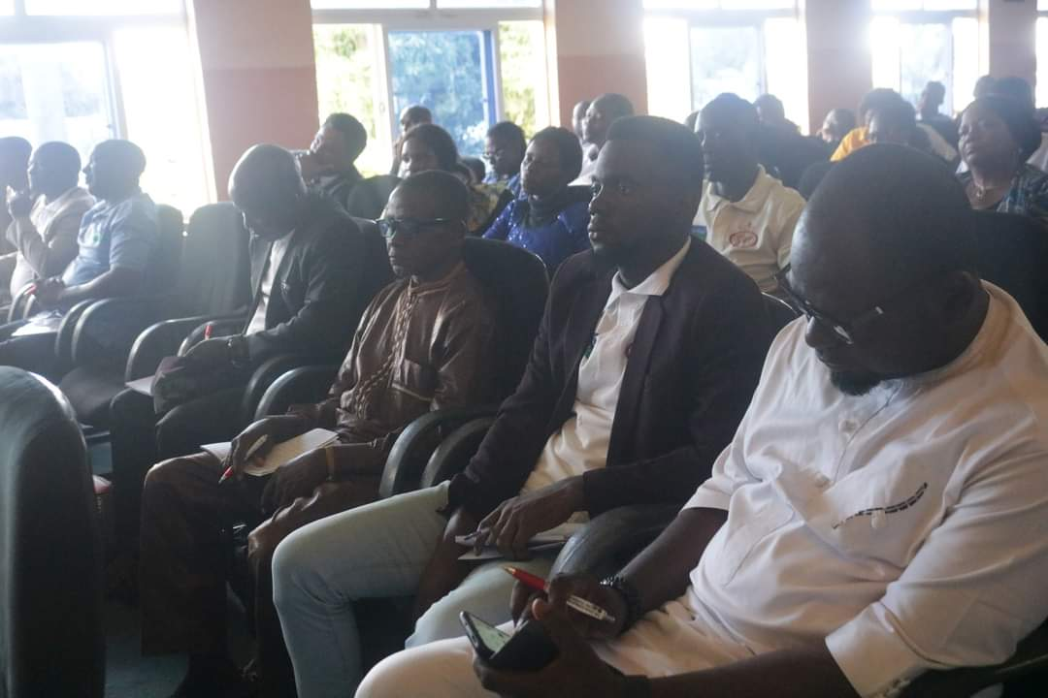
- Although early Christians ensured equity and justice in their community and continued the tradition of confronting wicked governance systems with the liberating truth of the gospel, the rise of the fundamentalist movement that sought to refocus the gospel on evangelicalism, placed the issues of social justice at the back seat leading to the gradual closing up of the Christian mind. she recommended the following as what can be done to promote social justice:
- We must first understand the holistic interest of God between human being and the earth,
- Man, and nature are supposed to live in harmony but because of the incidence in the Garden of Eden, the chain of harmony was disrupted. Yet God still desires to maintain a relationship with man.
Pic 8: Cross section of participants at the workshop
- We must recover and uphold the tradition of caring for others,
- We should not violate our call as a Church to reach out to the world,
- We have to become the change agents for the kind of things we love to see.

Questions and Responses
Questions:
1. When we are asked to speak out against social injustice, whom do we speak up to? And who is the relevant authority?
2. How do we start a shun corruption campaign?
3 How does PPJ support the setting up of social arm?
4. In a case where the church offering and tithe can’t run its weekly expenses, what do you do?

Responses:
1. Speak to God, government, persons in authority, church congregation and yourself
2. Start a social arm, look for people armed with knowledge of social advocacy
3. PPJ can give technical and training support. Pentecostal leaders can resolve to set aside money from tithes and offerings for social arms. Ministry is a dual mandate, spiritual and social dimension to create a balance.
4. Do evangelism, teach, pray, but if you’ve done all these and the church isn’t still growing then close it, and go into business but bottom line is that God always provides.

3.1.3 Module Six: Christianity and Accountability
The module on Christianity and Accountability was facilitated by Rev (Dr) Stephen Dangana. Some issues participants are to reflect on were given as follows:

- What is the meaning and essence of Christianity and Accountability?
- What is the connection between Christianity and Accountability?
- What is the cost of lack of accountability in Nigeria?
- What is the Role of the Church in Promoting Accountability?
- Are Christians accountable?
- Are Christians especially those of the Pentecostal persuasion ready to be accountable?
- What is the level of awareness and commitment by Christians, especially those of the Pentecostal genre, to the anti-corruption fight?
- Is it possible to mobilize Christians to be at the vanguard of the restoration of accountability as a directive principle of the national culture?

Rev (Dr.) Dangana started by explaining how accountability is important in our present time, he further stressed the fact that, whatever God has given someone is enough to produce what He has promised the person. Moreover, he defined accountability according to Professor Melvin J. Dubnick in a book titled Salvation for Accountability (2002), as: “an indicator of answerability, responsiveness, etc. But it is also indicative of the conditions it promises to create. Used in the appropriate context, accountability holds the promise of bringing someone to justice, of generating desired performance through control and oversight, of promoting democracy through institutional forms, and of facilitating ethical behaviour”. He also gave Richard Krejcir’s definition of accountability “as a check and balance system to protect us from harm, from ourselves and others”.
The module facilitator laid emphasis on the connection between Christianity and Accountability and gave some bible verses such has Matthew 18:23, Mathew 25:14-34, which talk about the parables of the unfaithful stewards. He went further to explain how Christ lived a life of accountability here on earth, and as Christians we are meant to emulate the life of Christ.
Rev (Dr.) Dangana, conceptualised accountability as stewardship (I Cor 4:2), and how accountability is a requirement for everyone, not just Christians. Accountability allows us to be answerable to God, oneself, society, colleagues, co-workers, a boss, small group members, pastor, and the community at large. Furthermore, he explained that Christian accountability is the realization that we are liable, responsible, and answerable for our actions in life to God (Matt. 12:36; Rom. 2:16; 1 Cor. 3:10-15; 4:5; 2 Cor. 5:10), as well as to key Christians in our lives (John 13:34 Gal. 6:1-2; Philip. 2:4; Heb. 10:23-24; James 5:16).
The role of the church in promoting accountability in Nigeria were captured as:
- Doctrinal Role
  - The Principle of Ownership.
  - The Principle of Responsibility.
  - The Principle of Answerability
  - The principle of Reward.
- The Role of Discipleship
- The Role of Sanctions

As part of the foregoing, the church and its leaders should do the following:
- Speak truth to power at all times, and not speak as sycophants;
- Take up the responsibility of raising people to mentor or coach business and political leaders who are Christians and encourage them to continue to grow in their faith and Christian maturity;
- Support Genuine Christians in political leadership and those who are credible in the eyes of the broader electorates;
- Preach openly against injustice, cheating and marginalisation of vulnerable and challenged persons who are easily exploited.

3.2 Closing for Day Two
Day two sessions and activities came to an end at exactly 3:45pm with a prayer said by a volunteer participant.

4.0 Day Three: June 15, 2023
On the third and final day of the programme, attendance increased tremendously as the day’s activities commenced with opening prayer and praise session led by a participant. This was followed by a recap of day two activities facilitated by Dr. Orinya Agbaji, Programme Manager, PPJ.

4.1 Technical Sessions
The following were the activities held during the technical sessions on the last day of the programme:

4.1.1 Module Seven: Christianity and Leadership
The module on Christianity and Leadership was facilitated by Dr. John Mbuka. The objectives of the module were stated as follows:
- To introduce participants to the concept of leadership, strategic leadership and the skills required for leadership competence.
- To examine the qualifications of leadership in the church.
- To explore requirements for making the church leadership relevant in the fight against corruption.

The module had the following as its outline:
- Introduction
- Understanding leadership
- Leadership and vision
- Leadership in the church
- Are you a leader or a person in leadership position?
Dr. John spoke intensively on the topic and defined leadership as the ability to influence others to achieve a pre-determined set of objectives. He proceeded to give the following as the common qualifications and requirements for leadership in the church:
- Spiritual qualification – indispensable, other qualities are desirable
- Moral requirement
- Domestic and family life
- Doctrinal requirements
- Social requirements

The facilitator added that the leadership of any organization determines whether the organization will succeed or fails and, in the church, God is the ultimate leader and he calls every believer to lead. He noted that our failure in not accepting to lead endangers the life of people around us. Leadership according to Dr John, is the most important variable that affects every organization. To facilitate a clear understanding of who a leader truly is, the facilitator drew a distinction between ‘being a leader’ and ‘being a person in leadership position’ - like the manager of a project. He also emphasized that everything rises and falls on leadership thus confirming the strategic role leaders play in any organisation or society. The leadership styles captured in the bible were identified as follows:
- Apostle – establish new works and new leaders.
- Prophets – speaks God’s word to inspire, correct and motivate.
- Evangelist – shares Christ with others and trains others to do so.
- Pastor – a shepherd who guides and guards God’s people as they serve.
- Teacher – one who trains God’s people in truth and teaches others to do so.
- Deacons – Greek word meaning servant or slave of a king especially one who acted in the capacity of a waiter or messenger.
- Social ministry (ministering to needs of people) and pastoral help.

Dr John enumerated the qualities of a good leader as follows;
A leader should be generous, charismatic, passionate, communicate well, dogged, listening, initiative, courageous, self-discipline, ability to solve problems, teachable, visionary among others.

4.1.2 Module Eight: Christianity and Fight against Corruption
The eighth technical presentation at the workshop was on Christianity and Fight against Corruption, was presented by Dr John Mbuka, who laid emphasis, on how Christianity and Corruption shouldn’t be mixed. He defined Christianity as a religion based on the person of Jesus, and when one reads the bible, he will understand Jesus personality. Christianity according to him, lays emphasis on light, how we should live a holy and righteous life, while corruption lays emphasis on darkness. The Purpose of the training was given by the module facilitator as follows:

- To have a broad and deep understanding of the content of corruption outside and within the context of the Pentecostal church
- To develop a share and common understanding of how to fight corruption within and outside the Pentecostal church
- To determine how the Pentecostal can organize into an effective movement for the fight against corruption
- To examine corruption in the light of the scripture
- To understand the concept of Trinity in the fight against corruption

The outline of the presentation was stated as below;
- Corruption
- What is corruption?
- Corruption through the ages
- The effect of corruption
- The scriptures on corruption
- The role of Pentecostal church in the fight against corruption
- Conclusion
The presenter gave some reflections to consider, before the session began in earnest as follows:
- What is corruption?
- Is their corruption in Nigeria?
- Can there be corruption in the Pentecostal church?
- What constitute corruption in the Pentecostal Church?
- Can the Pentecostal church fight corruption?
- Should corruption be minimise or eradicated in the Pentecostal church, and if can be minimised or eradicated, who should take the lead?
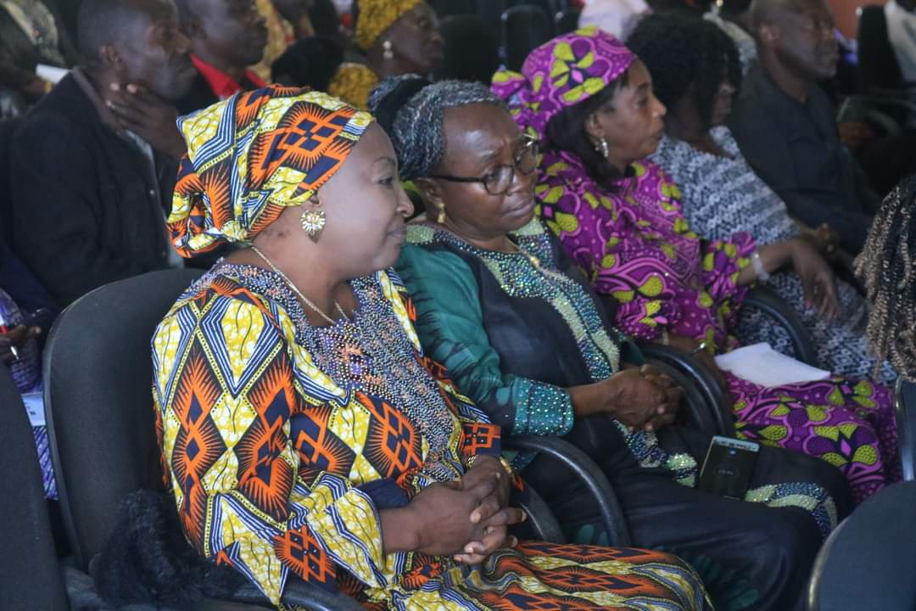
Dr. Mbuka spoke passionately about corruption stating that in recent times the fight against corruption has become a global one that can be referred to as a pandemic owing to the fact that it has eaten deep down into the fabrics of the society. He added that despite the plans put in place in the last 25 years to tackle corruption, nothing tangible has been achieved as it still remains a menace in our present society. He went further to define corruption according to Oxford dictionary as: “a dishonest or illegal behaviour, especially by people in authority”. He noted that the various laws including the constitution, criminal code and anti-corruption law did not define corruption, instead they pick an aspect of corruption such has nepotism, abuse of power and bribery. He went on to define corruption according to world bank as, “the abuse of public office through the instrumentality of private agents, who actually offers bribe to circumvent public offices and policies for competitive advantage and profit”. Dr. Mbuka explained that the bible in James 4:17 defines corruption in complete term as “knowing what you ought to do, and not doing it”. The facilitator noted unfortunately that countries that are known to be corrupt or have a high corruption index, experience a low or no investment from foreigners due to fear of the unknown and this in turn affects the economy and livelihood of the people.
Pic 9: Some female participants at the workshop

Questions and Answers
- Can Pentecostals win the fight against corruption? Also, why are Christian bodies setup to fight corruption not achieving success?

Answer
- Pentecostals can win the fight against corruption …it is very possible, because the Pentecostal church can do all things through Christ who strengthens them. Prayer is the major key to fighting corruption. We should encourage persons within the church that contribute towards the fight against corruption to keep doing so.
In conclusion, the facilitator said it was very clear that we live in a society where corruption has engraved itself in the culture of the people. Therefore, Christians should not only condemn the practice but show good examples through their honest lifestyle. They must also harness the values of work, business, and investment and look for legitimate source of income.

4.1.3 Module Nine: Investment and Income Generation
This important module was presented by Rev Alex Baba. The objectives of the module were stated as follows;
- To establish a scriptural context for managing businesses
- To share case studies of how churches are using businesses to create more wealth for the benefit of members and the ministry
- To examine several business models that can be adopted
- To determine how to Select businesses that is suitable for ministries
- To know how to plan for a successful launch of the business
- To know how to manage a business effectively
- To know where to source for financial and technical help for the ministry
- To know how to run a Micro-credit scheme for members
The module was presented through the following 5 segments:
- Introduction
- The Foundation
- The Structure
- The Process
- The Closing

1. Introduction:
By way of introduction, the presenter noted that poverty level in the church is very high, contrary to the blessings reported in the bible. The segment focused on the following;
- Promises
- Blessings
- Reality Check

He observed that tithes and offering are not the major funding in churches. Some churches result into gimmicks, why some overstress bible verses, to scoop more money from members.
He asked participants to reflect on the following questions:
- Can you remember when last your church wasn’t in a deficit?
- How are you fairing financially?
- Do you know how your fathers in the faith are faring financially?

Rev Baba added that:
- It is unfortunate that people often say “as poor as a church rat” whereas the Pentecostal churches in Nigeria have a shared economic base of approximately N45billion, with a membership of about 45 million persons
- The session will explore ways and means, the church (Pentecostal) can create and distribute wealth in line with the covenant promise as seen in Deut 8:18, Eccl 2:26.
- Wealth generation is crucial today if the church is to attain a level of independence essential for ministry growth and church leaders and workers would be free from the encumbrance that comes with the frantic search for money to run the personal expenses of the ministers as well as part of the ministry.

2. The Foundation:
This segment was presented, by stating its focus as follows;
- Business Environment
- Economic Outlook
- Biblical basis

The facilitator noted that poverty in the church needs to be terminated, by enriching pastors and their members with ways of making wealth positively, in return, this will help to reduce corruption found within the church. Nigeria is thought to be the largest economy in Africa (Accounting for 20% of its population), the economy is currently in Recession which provides its own peculiar opportunities for smart entrepreneurs. He encouraged participants to explore other environment such as Agric, Real Estate, Solid Minerals, Manufacturing, and not only in the Oil sector. He introduced the concept of “Mindset Shift” with a saying that “For as he thinketh in his heart, so is he” which is recorded in the book Prov 23:7. The mindset shift, is aimed at repositioning Christians believe on the market place, and whether they should be wealthy or not. A formula was given to help Christian change their mindset and achieve success. It is expressed as;
BExDO=Have,
Where BE stands for Believe and DO= Have
This can be further summarised below;
- Mindset – as a man thinketh in his heart – What is your thought on making money?
- Values – your sense of right or wrong – do you believe in using people or having a win-win scenario?
- Beliefs – things you hold to be true (world view) – what does money represent to you?

He went further to explain the biblical studies in two major parts;
- Theology of work
- Ministry tool

He also explained, how money is important, and the advantages attached to it. Money is a powerful tool for influence and plenty of it makes a person rich but understanding the principle makes a man wealthy, knowing how to use it makes him powerful. Using it for the kingdom earns him eternal value (Lk.16:9). Proper disposition to money defines a man’s spiritual values (Matt.19:21-24, 1Tim. 6:10). Moreso, he explained how God is using the business platform for the Transfer of wealth from the world to the Church, by making reference to some biblical verses such as Zech. 1:17; Haggai.1:1-11, 14, 2:6-9; 1Kgs.17:8-16; 1Chron.29:1-5; Eccl.2:26; Deut.8:18, 14:28-29, 15:10-11; Psa.35:27; Prov.13:22.

3. The Structure
The structure according to Rev Baba, is aimed at developing a productive economic plan or model, and activity that will be integrated into the church, which in turn will support Christian ministry. The phenomenon of "Kingdom business," though relatively unknown, has seen successful implementation in the church since Apostle Paul first discussed his own work habits in his letters to young churches. He was quite clear that people should work to make a living, and returns to this theme in the second letter to the same church of Thessalonica, where he says, "If a man will not work, he shall not eat." (II Thessalonians 3:10). But this is not always so easy to put into practice (either working or eating!) in a world where poverty and unemployment are common place. The segment was presented by stating its focus to include;
- Platforms
- Programmes
- Provisions
Models are needed to combine economic development with a clear focus on holistic Christian out reach. They need to be integrated with church ministry and a clear emphasis on Christian witness. Some models the church can use for wealth creation are as discussed below:

- Ministry Service Businesses - the development of self-sustaining enterprises such as Christian clinics, dental offices, schools, and bookstores, where the ministry charges a fee for services.
- Ministry Endowment Enterprises – the development of farms for agricultural purpose such has poultry, ranches and so on, to help sustain the church
- Tent Making Enterprises - to provide legal entry, financial support, and a ministry context for expatriates
- Business Incubators - the creation of new businesses for target populations needing income or employment, but not having a background or experience in productive economic activity.
- Micro Credit Programs - revolving loan programs for people who have a business idea, and usually some experience, and who, with an additional capital, can generate funds to pay back the loan with interest.

4. The Process:
The process is aimed at identifying a productive economic plan or model, where will it be suitable to establish such institute, and integrate into the church, which in turn will support Christian ministry. This segment was presented by stating its focus, which are shown below;
- How
- Where
- When

The church should be able to know where to invest, how to source for funds, and what period should their economic plan take off as discussed in the previous model, which lay emphasis on the structure of having a robust economic plan or model.

5. The Conclusion
Rev Alex Baba explained that funding is an important aspect for any business to grow. He added that the business owner is in the right frame to determine, whether the business needs funding or not. The banks, government, and other organizations are there to provide funding for businesses to thrive. Failed businesses are mostly tied to poor management, and untimely funding.

This segment was presented by stating its focus, which are shown below;
- Business Environment
- Economic Outlook
- Comparative Advantage
The presenter listed some institute where participants can get loan to maintain or start a business, but he advised that all business should be well x-rayed, and the cost, knowledge and necessary skiils needed to start a business should be evaluated before indulging; funding opportunities include
- CBN’s N500bn Power/Aviation funds & Refinancing/Restructuring funds for the Manufacturing Sector.
- $500m Nigerian Small & Growing Business Loan Scheme
- N100bn Cotton, Textile & Garment Industrial Revival Scheme
- N10bn Rice Processing Special Intervention Fund
- N18bn National Automotive Development Fund
- N5bn MSME Business Development Fund on behalf of Dangote
- N3bn MSME Development Funds for 9 states – Niger, Delta, Kogi, etc.
- N200bn Sugar Development Fund
- N90m Business Development Fund on behalf of Federal Ministry of Women Affairs & Youth Development
- N50m fund on behalf of SMEDAN
- N4.3bn Cassava Bread Fund

He advised participants, to make enquiries about the listed funding opportunities and apply. He also listed some other forms of funding which include:
- Personal savings: The primary source of capital for most new businesses comes from savings and other personal resources. While credits are often used to finance business needs, there are usually better options available, even for very small loans.
- Friends and Relatives: Many entrepreneurs look to private sources such as friends and family when starting out in a business venture. Often, money is loaned interest-free or at a low interest rate, which can be beneficial when getting started.
- Banks, Credit Unions or Co-operative: The most common sources of funding, banks, credit unions or co-operatives, will provide a loan if you can show that your business proposal is sound.
- Stock/Personal Assets: You can use your share certificates or assets as security for loans or dispose of them to raise capital for your business.
- Angel Investors and Venture Capital firms: These individuals and firms help expanding companies grow in exchange for equity or partial ownership.
- State/Sector-Specific Economic Development Programs: Government programmes like the SMIES, organizations like NAPEP, SMEDAN, BOA, BOI, AGSMEIS, N-Power, Covid-19, etc.
- Micro Finance Banks – Since 2005 when the Govt launched the Microfinance Policy, there have been several of these. The beauty of these banks is that you can borrow up to N500,000 without a collateral. Just provide a guarantor. Also, it is easier to access funds through group lending.
- Gender Specific Funds – There are several intervention funds out there as at today. Currently, BOI and the MFBs have funds that can only be accessed by women.
- Grants & Donations – YouWIN, SURE-P, BidNet, etc.

In conclusion, he highlighted some important points that summarise all the discussed segments to help explain the aim of the module, which is centered on Income Generation and Investment. He closed by giving participants the underlisted guides to developing a sound economic platform for the benefit of the individual and the church;
- Have a Productive Idea
- Develop the Appropriate Skills needed to grow the idea
- Draw up a Business Plan
- Have a Financial Plan
- Seek God’s help & Guidance – 2Chron.26:15
- Be conscious of the kingdom mandate – Matt.6:33
- Start small while thinking big!

Question and Answer session
- There is this a friend who invested in the stock exchange in the past but he can’t seem to assess it or even know what happened to it, how can he be helped?
- I sold a piece of land so I can re -invest the money on a new business. Should I pay tithe on it?
- Participants should endeavour to start up a business small and not be ashamed, … in her words, “break the mindset of your limitation”.

Response
Don’t invest on what you don’t understand - it is a rule
There’s a huge difference between stock and shares, one is for trading and the other is for keeping
2. Tithe is paid on your increase. Put your money into the business when it yields then you can use it for kingdom activities

4.2 Next Steps, Expected Outcomes and Feedback Mechanism
A brief session on next steps which included - expected outcomes, mechanism for feedback to PPJ as well as signing of pact against corruption was taken by Ms. Ojonogwa Negedu – Programme Officer, PPJ. She reiterated the need for participants to work together to promote the fight against corruption. In terms of next steps, the following were noted by the Programme Officer:
- Participants should key into the radio programme on 104.5 FM Abuja called Voice of the Priest (VoT) where anti-corruption messages are passed on to the listening public weekly.

- There are three national WhatsApp platforms participants are encouraged to join if they are not there already. They are: Ministers Against Corruption; Christian Women Against Corruption; and Youth Vanguard Against Corruption. Those who are not on any of the platforms should drop their contact details so that they can be added.

By way of expected outcomes, the following actions were identified as evidence of success:
- Shunning corruption – take no part in corrupt practices/corruption
- Speaking against corruption – see it as sin against God and injustice to man
- Standing up against corruption
- Support marches, rallies and events organised against corruption,
- Resisting corrupt practices,
- Sharing testimonies of unsuccessful attempts to be corrupted,
- Sharing sermons preached on corruption or evangelism outreach carried out on the subject of corruption,

PPJ’s feedback mechanism were given as follows:
a) Social Media
- Facebook: PPJinitiative
- Instagram: @Priests Peace and Justice
- Twitter: @Priestspeace

b) Email/Telephone
- info@priestsassembly.org
- Orinya Agbaji – agbaji2016@yahoo.com (0806-845-5697)
- Amina Mbuka – amivet2007@yahoo.com (0803-397-5151)
- Ojonugwa Negedu – onegedu@priestsassembly.com (0902-811-7971)

Two copies of the endorsement pact were given to each participant to complete in demonstration of their commitment to join the fight against corruption. They were also required to return back a copy while the other copy should be kept for themselves.

4.3 Closing Session
Activities that marked the closing session of the programme were captured as follows:

4.3.1 Administration of Post Test and Workshop Evaluation Questionnaires
As part of the closing activities, two questionnaires were administered to participants. The first was post-test evaluation while the second was workshop evaluation questionnaire. The essence is to measure knowledge gained from the workshop as well as evaluate the performance of the programme in general.

4.3.2 Closing Remarks and Prayer
The Programme Manager, Dr. Orinya Agbaji in his closing remarks, highlighted the following
- Created awareness about the forthcoming African Anti-Corruption Day which is observed on July 11 annually and requested participants to reserve the date and plan to take part in activities to mark the day.
- Thanked participants for their active contributions to the success of the workshop and encouraged them to engage and be active on the various WhatsApp platforms set up to spread the anti-corruption message among Pentecostal Christians.

Closing remark was said by Rev (Dr) Stephen Dangana represented by Rev. Dunka Gomwalk, PFN Chairman (elect) of Plateau State. Prayers were said at exactly 4:05pm by Elizabeth Gomwalk to bring the programme to a close. Participants thereafter dispersed to their respective destinations.

