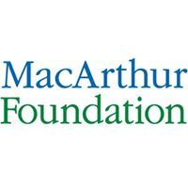

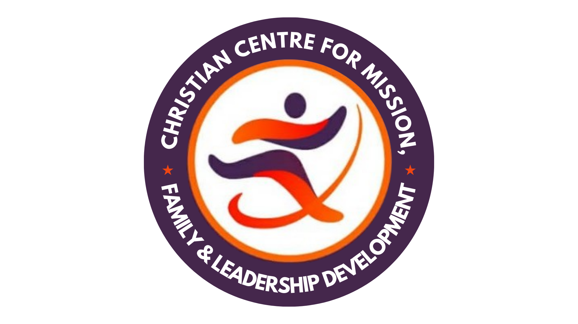
A Report of

Platform on Transparency & Accountability
for Christians in Government
with the theme:
Beyond Corruption: Pentecostal Unity
for Social Justice Advancement

Organised by
Priests Peace and Justice Initiative (PPJ)
in partnership with MoHR, CEMFLED & SCM
With the Support of MacArthur Foundation

Held at
De Silver Green Luxury Hotel, Abuja
February 15, 2024

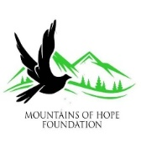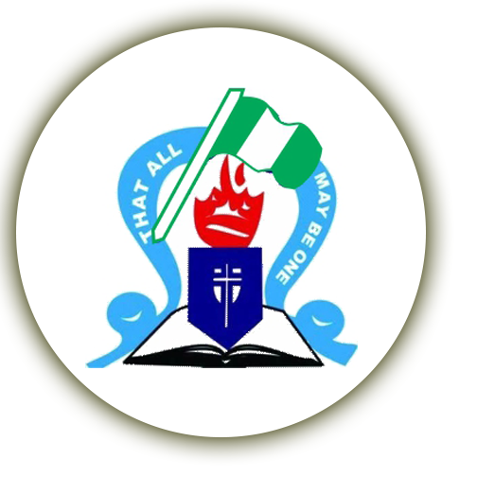
Table of Contents
1.0 Preamble 3
2.0 Opening Session 4
2.1 Welcome Address and Goodwill Messages 4
2.2 Introduction of the Shun Corruption Project 5
3.0 Technical Session 6
3.1 Beyond Corruption: Pentecostal Unity for Social Justice Advancement 7
3.2 Panel Discussion Session – Leveraging Christian Participation in Government for the Advancement of Social Justice and Policy Advocacy 9
3.3 General Questions, Comments and Responses 12
4.0 Closing Session 14
4.1 Next Steps and Feedback Mechanism 14
4.3 Administration Evaluation Questionnaire 15
4.4 Closing Remarks and Prayer 15

1.0 Preamble
Priests Peace and Justice Initiative (PPJ) is the social arm of Palace of Priest Assembly (PPA), a notable Pentecostal Christian mission in Nigeria. The initiative was conceived to promote the building of a peaceful, just and orderly society, and uphold the dignity of the human person as created by God. As a Faith-Based Organisation (FBO), it is the duty of PPJ to bring biblical perspective to the challenges of democracy, development, insecurity, injustice, service delivery and humanitarian crisis. The vision of PPJ is: ‘a world of prosperity and social justice’ while its mission is: ‘to act as catalysts to empower citizens to reign as Priests and work for peace and social justice’. Guided by the values of leadership, empowerment, royalty, integrity and discipleship, PPJ has the following five areas as its thematic focus:

- Democracy: Elections, transparency and accountability and stewardship.
- Peace Building: Human Security and Conflict transformation.
- Social Justice: Poverty, Inequality and Justice.
- Emergency and Humanitarian services.
- Education and Health.

The Platform on Transparency and Accountability for Christians in Government is a programme that aims to create a collaborative space for the recognition, celebration, and cooperation among Pentecostal leaders and workers in government dedicated to upholding integrity and combating corruption. The specific objectives of the programme include:
- To acknowledge and celebrate Pentecostal leaders in government demonstrating unwavering commitment to integrity and ethical governance.
- To foster networking among Christian professionals in government, encouraging the sharing of experiences, best practices, and strategies for ethical governance.
- To inspire positive change within the government sector by showcasing the impact of Christian leaders committed to ethical principles.
- To contribute to the promotion of ethical governance in Nigeria by highlighting the role of Christians in government and their impact on societal development.

The meeting was convened by Priests Peace and Justice Initiative (PPJ) in collaboration the Mountains of Hope Foundation (MOHF), the Christian Centre for Missions, Family and Leadership Development (CEMFLED) and the Students Christian Movement (SCM) of Nigeria.

2.0 Opening Session
The programme which was held at De Silver Green Luxury Hotel, Abuja February 15, 2024 with the theme - Beyond Corruption: Pentecostal Unity for Social Justice Advancement opened at exactly 10:00am with a prayer and praise session led by Pst Oche Ocheme and Pst Ruth Bano respectively. The programme had over 60 participants in attendance composed of Pentecostal Christian leaders and those who work with government as well as the media.

2.1 Welcome Address and Goodwill Messages
Welcome address was delivered at the meeting by the Programme Director, PPJ – Pst (Dr) Otive Igbuzor. He gave a brief origin of the Shun Corruption project funded by Mac Arthur, conceived by PPA but implemented through PPJ – the social arm of PPA. Pst Igbuzor bemoaned the problem of corruption in Nigeria which according to him has reached an unprecedented dimension. He informed participants that the programme which is in its final lap has achieved the following among others:
- Harvesting of 115 scriptures that capture the meaning of corruption and the imperative to adhere to the standards of honesty, integrity and transparency expected of Christians.
- Training of a total of 2,892 Pentecostals on the need to Shun Corruption.
- Endorsement of the pact on Transparency and Accountability by 1,186 Pentecostals.
- Supporting 91 Pentecostal churches to establish social arm of the church to fight corruption and address other social justice issues in the society.
- Establishing of 61 anti-corruption platforms including Ministers against Corruption, Christian Women against Corruption and Youth Vanguard against Corruption.

In closing, Dr Igbuzor informed participants that a presentation was made to the National Executive Council of PFN as part of the initiative to sustain the shun corruption project. He concluded by expressing hope that Christians in government present in the programme would sign on to the anti-corruption pact prepared by PPJ.

Goodwill messages were delivered at the programme by the following:
- Mrs. Essiet Abiodun – SSA to the President on Community Engagement – North Central Region
- Mrs Funke Oladipo – Federal Ministry of Women Affairs and Social Development
- Mrs Ebere Ubesie – SCM
- Rev Isaac Komolafe - CEMFLED
- Pst Esther Dogonyaro - MoHF
- Prof Mabel Evwierhoma – PPJ
- Rev Itia Otabor – Centre LSD
- Dr Amina Salihu - MacArthur Foundation

In their respective goodwill messages, Pst Dr Otive Igbuzor was commended for the initiative to set up PPJ as a social arm of PPA to address issues of social injustice particularly as it relates to promoting accountability and transparency among Christians in Nigeria. Specifically, Mrs. Ubesie, President, SCM spoke on the need for Christians in government to promote the gospel while Rev Komolafe, Executive Director, CEMFLED charged participants to be inspired to uphold integrity and combat corruption in all its forms, knowing that the efforts today will shape the future of Nigeria for generations to come. Similarly, Pst Esther Dogonyaro, Executive Director, MOHF called on participants to heed to the call to action and leverage their Christian ethics and principles to guide their conduct in government service. On her part, Prof Mabel Evwierhoma – board member, PPJ encouraged participants to take forward the message of transparency and accountability to promote good governance. Quoting the Holy Bible from the book of John 14: 30; Rev Itia, Strategy Director, Centre LSD encouraged participants to always ask themselves if they would be found worthy if the Prince of the world came to examine their works. Lastly, Dr Amina Salihu of Mac Arthur Foundation spoke passionately on the need for participants to see corruption beyond the prism of religion or ethnicity and emphasised the need to demonstrate dignity in practicing their faith.

2.2 Introduction of the Shun Corruption Project
A session on the introduction of the SHUN Corruption project was facilitated by the Programme Manager – Dr. Orinya Agbaji. The presentation touched on the origin of PPJ as a social arm of PPA and looked at its mission and vision. The presentation also gave an overview of the Shun Corruption project which is being funded by Mac Arthur Foundation as part of its Big Bet On Nigeria project. The programme Manager explained the fact that the first phase of the project ran between 2018 and 2020 with an extension to May 2021 while the second phase which commenced in September 2021 will end in 2024. Dr Orinya explained that the overarching goal of the project is to promote zero tolerance to corruption among Pentecostal Christians through adherence to positive group norms, peer-to-peer accountability, and institutionalization of platforms against corruption. The specific objectives were identified as follows:
- To promote the establishment of the social arm of the church as an instrument for fighting corruption and adopting accountability framework for Pentecostal churches.
- To enhance the capacity and capability of the Pentecostal Community in Nigeria to adopt social arm of the church and accountability framework within the church and champion the fight against corruption outside the Church (in communities, towns, unions, workplaces, academic institutions, marketplaces, etc.).
- To enhance ‘voice’ and ‘agency’ of Pentecostal leaders and workers as active citizens performing their civic duties, participating in politics, elections, and governance in Nigeria.
- To activate Pentecostal campaign platforms visibly taking collective action against corruption.
- To promote behaviour change among Pentecostal Churches regarding accountability within and outside the church.

The PM added that at least 103 churches have already set up their own social arm and they were trained on how to go about doing the work. The following were some of the achievements of the project highlighted in the presentation:
- The emergence of new cultures by individual Pentecostal leaders in various sectors to shun, speak and stand up against corruption.
- Many of the beneficiaries have shown great signs of shunning and speaking up against corruption; some have demonstrated great ability to stand up against corruption.
- Implementation of the project in 26 states out of the 36 states of the federation of Nigeria.
- Conduct of several researches on drivers of corruption within and outside the church as well as on other interesting aspects of tackling corruption.
- Establishment of several platforms against corruption like women against corruption, ministers against corruption, youths against, etc.

3.0 Technical Session
The keynote presentation which formed the nucleus of other discussions at the meeting was delivered by Prof Samuel Zalanga - an emeritus professor at Bethel University and a Lecturer at Luther Seminary St. Paul Minnesota, United States. This was followed by a panel discussion session as well as an open interaction that provided participants with the opportunity to engage and contribute to the discourse. The activities during the technical session were as follows:

3.1 Beyond Corruption: Pentecostal Unity for Social Justice Advancement
This session was facilitated by Prof Samuel Zalanga who joined virtually from Minnesota in the USA. The presentation had the following outline:

- What is Corruption?
- Some consequences of Corruption
- The Causes of Corruption: Reflection from Church Leaders and Theological Educators in Africa
- The Causes of Corruption: Some Insights from the Humanities and the Social Sciences
- Catholic Social Teaching Principles and Approach to Justice
- Protestant Response to Catholic Social Teaching and Approach to Justice
- Conclusion

Prof Zalanga conceptualised corruption as moral failure which means to spoil, pollute, abuse or destroy something. He added that corruption is an aberration from societal norm and an inappropriate behaviour by someone holding a position or an office. Some of the consequences of corruption highlighted by the speaker include the following:
- It decisively affects service delivery, quality and access to public goods.
- It discourages foreign donors or business partners who would not want to see their money wasted.
- it promotes exclusive development instead of inclusive development which in turn leads to tension and resentment.
- It increases the degree of inequality in society between the rich and the poor.
- It makes those marginalized to not recognize the legitimacy of societal structure and power distribution.

Based on a study conducted among Church Leaders and Theological Educators in Africa and insights from the humanities and the social sciences, some causes of corruption were identified as follows:
- Being in company of bad influences
- Institutionalization and normalization of extortion
- Vitiation of the human heart and mind
- Misrepresentation and misuse of the word and image of God by people
- Weak institutions of social control and absence of justice
- Distrust in leadership among others

The emeritus professor concluded by noting the following:

- Without justice, we are all a gang of robbers, metaphorically speaking.
- We need an interdisciplinary and interdenominational approach to understand corruption and justice.
- Moral and ethical cultivation is a fundamental requirement to controlling corruption.
- Corruption and justice cannot be achieved without effective institutions.
- The church should not take capitalism and the market, especially, in their neoliberal incarnation for granted.
- The approach to justice by the church and Christians in general should not be narrow but from the broad understanding of humanity
- Finally, “A kingdom can survive unbelief” but it cannot survive injustice

Questions, Comments and Responses
The following were comments made and questions asked by some participants:

- It has been noticed that accepting correction is a difficult thing especially when the person is in a position of authority. How do we act or approach issues of wrong doctrine or scriptural corrections?
- How can we manage the understanding that everything is not about being heavenly minded only?
- How can we influence the theological curriculum and training to address a wholistic view of our mission as Christians?

Responses
- In the western world, pastors do not see themselves from a larger than life frame. Unfortunately, the reverse is the case in Africa as it is mixed with tradition. A minister not willing to accept correction can be corrected by members through exemplary living – by doing the right thing. Therefore, it is good for people to have a good knowledge of the bible and the word of God in general so that they can know what is wrong or right and act accordingly.
- The first-place corruption takes place is in the desire of the flesh and if it is allowed to conquer one, it will set in.
- It is not enough to preach in the church but to model what you preach. The origin of injustice is in the self.

3.2 Panel Discussion Session – Leveraging Christian Participation in Government for the Advancement of Social Justice and Policy Advocacy
A panel discussion session on the topic: Leveraging Christian Participation in Government for the Advancement of Social Justice and Policy Advocacy was moderated by Pst (Dr) Ejiro Otive-Igbuzor, Assistant General Overseer, PPA. She introduced the following as members of the panel and invited them to join her on the discussion desk:
- Prof. Adeosun Clement
- Mrs. Ebere Ubesie
- Rt. Hon. Olubunmi Adelugba
- Pastor (Mrs) Ese Irhezean
- Rev Isaac Komolafe
- Prof. Mabel Evwierhoma

The panelists were asked different questions depending on their unique experience and field of service. Below is a summary of the panel discussions:

Question 1: How can Pentecostal leaders effectively engage with policymakers to influence the development and implementation of policies that align with ethical principles and contribute to social justice advancement?

Rt. Hon. Olubunmi Adelugba: To engage policy makers and influence policy decisions, Pentecostal Christians should consider the following:
- Building relationship with policy makers and policy making institution.
- Pentecostal Christians need to understand policy landscape to be able to play effectively.
- Issues being canvassed should be communicated clearly and with compelling evidence or proof.
- Collaborate with likeminded individuals and organisations and engage those pursuing similar interest as yours.
- Engage in grassroots mobilisation – find out what is happening and show genuine interest in matters of interest to them.
- Promote expertise and support leaders when they are preparing to go to power.
- Be persistent despite the challenges and discouragement that may come.
- The need to encourage members to go into politics
- Carryout advocacy from the pulpit as well as media engagement
- Identify and champion scriptural verses that can be used to advance their cause.

Question 2: How open is the government to receiving policy recommendations from religious organizations like the Priests Peace & Justice Initiative, and what mechanisms exist for ensuring the incorporation of these recommendations into the policymaking process?

Prof. Mabel Evwierhoma
It depends on the leadership style of the religious organisation. Generally, churches should be appreciated for keeping people from rocking the system and causing chaos. It is apparent that government like to listen to people who put pressure on them e.g. when the international community bring policy advice, government seems to respond easily. On the contrary policy recommendations from religious organisations are unfortunately not taken seriously because many Christians are not aware of the business of government and governance procedure as enshrined in the constitution. The cross-cultural institution like the Federal Character Commission, NYSC, etc. are not totally and appropriately woven as they should be. Looking at a faith-based organisation like PPJ, there are lots of social and moral capital it has to deal with the incorporation of policies. Therefore, leveraging on its social and moral capital, PPJ was able to push some policy advancements. The products developed from its research and other programmes like manuals, policy brief, etc. could be sent through the legislator representing its constituency in the Assembly to advance policy issues. Also, there should be a balance between religious and social activism to be able to shape policy. The important thing here is to avoid any form of discrimination by castigating fellow Christians. It is germane for FBOs to critically look for issues they can take up and refrain from working in silos. Christian organisations should not be silent about issues they find appalling. Vocal persons in their midst should be made to articulate their issues and advance their cause. It is always ideal to cast your net wide because you never can tell where and when the expected change will come. In summary, successful organisations like PPJ should endeavour to support others to support funding and other resources to enable them push and advocate social issues that could be used to pursue policy change.

Question 3: Are there international best practices or policy models that can be adapted to the Nigerian context to strengthen the role of Christian workers in promoting social justice and integrity?

Mrs Ebere Ubesie: Practically every mission is built on something. The biblical rule of loving your neighbour as yourself is key irrespective of any international protocol or framework. The time has come for people to know us as Christians through our conducts. There was a time I travelled out of the country and was abiding by joining queues to get services but the moment I came back to Nigeria, I realize I would miss my flight if I acted as I should. It is always appropriate to apply the teachings of the bible to oneself first before accusing others or subjecting them to same principle. Some of the moral teachings are upheld by non-Christians for example visiting the sick and those in jail. If we as Christians are not able to abide by this injunction, where then lies our Christianity?

Question 4: From your personal experiences, what policy changes or improvements would you recommend to better facilitate the integration of Christian values into your work, particularly in the context of combating corruption and promoting social justice?

Pst (Mrs) Ese Irhezean: Enforcement of effective leadership. Leaders should understand why they are in position of authority? It is only in such situation that subordinates become loyal. Many persons love to occupy leadership position without performing the required task. Another critical point is discipline. When people know that they can be disciplined for wrong conduct, they will refrain from it. Your colleagues can hate you simply because you clock the correct time you report or close for duty. I once had an experience in which I was redeployed to a duty just to get to my boss but I took it in good faith and eventually, another superior officer had to intervene for me by vouching on my faithfulness to the job which he had observed earlier on. There is also the need to be fair and abhor any form of partiality in the place of work.

Question 5: How can Christian leaders within government institutions effectively leverage their positions to influence policy changes that promote social justice and ethical practices, considering the unique challenges and opportunities they face in their roles?

Rev. Isaac Komolafe: Matthew chapter 5 verse 14 says we are the salt and light of the world. Salt does not struggle to season whatever substance it is deposited so also; light does not fail to shine in whatever darkness it is placed. Imbibing Christian values in its totality is very critical in advancing for changes in policy institutions. Many people simply indicate that they are Christians without acting it out. It is said that there are over 50 million Pentecostal Christians in Nigeria, but how many are really acting it out and showing that they are really Christians? Another way through which Christians can leverage their position to influence policy change is through networking and collaboration. It is critical to work with other Christians in government institutions to form a formidable group that can push for change as it is often said a bunch of broom is difficult to break. Developing expertise in policy formulation is yet another strategy for Christian leaders to influence policy change. Identifying strategic opportunity to carry-out policy influencing is equally important. Finally, being persistent and resilient in the issues we seek to change without giving up is a way to influence policy. Others to consider are:
Balancing faith – Religion can promote good governance but we sometimes keep religion by the side on week days rather than carrying it along wherever we go.
Being conscious of what is preached - Pastors and church leaders should be conscious of what they preach and teach their members. The orientation of pastors should be set right to ensure that what they feed their flock with is functional and upright.

Question 6: Are there examples of successful collaborations between Christian leaders and policymakers in other regions that can serve as models for the Nigerian context?

Prof Adeofun Clement: There is paucity of successful collaborations between Christian leaders and the government in literature. There is always a separation of the church and the state even in countries like UK and Italy where religion is known to be somehow fused with government. The bible admonishes that there should not be too much collaboration to minimise corruption of Christian leaders. However, I personally support collaboration between the church and government but unfortunately many of the things that work well outside Nigeria may not thrive in Nigeria. The scriptures in Matt 7:25 – 27; Mark 6: 25 – 27 and Dan 3:14 – 29 touch on how to relate with policy makers as Christian leaders. To collaborate with government on policy making, Christian leaders need to be more enlightened. They should speak with one voice so as to be heard loud and clear to make impact. They should bear in mind that every government want legitimacy from citizens so, they are most likely to be accepted if they propose to work with government on policy of interest to them. If Christians come together to be a formidable force, they can make statements that resonate in their area of interest.

3.3 General Questions, Comments and Responses
In response to the discussions by the panelists, the following comments and questions were made/asked by participants:

- The operations of many churches are shrouded in secrecy and not accountable to their members. This limits the voices of members. Also, the church seems not to be investing as it should be doing. They simply use their monies the way the general overseer wants.

- It has been observed that the church does not often put their best foot forward rather they are often self-centred and allow emotions to get the better part of them. This should not be the way to go about issues.

- The church should be ready to pay the price and make sacrifices for greatness. The Pentecostal body should be willing to speak with one voice in order to be heard and taken seriously.

- If a Christian writes a promotion exam, passes well and he or she is being asked to pay something to be promoted. What do you expect the person to do?

- Christians – especially the Pentecostals need to be united and learn to accept one another irrespective of denomination. In the midst of the several issues troubling the nation like the $6.2million paid to foreign election observer by CBN through a forged memo from the SGF office, past governors embezzling millions of dollars and many more, the Christian body should make their position clear on these anomalies.

- It is heartening that PPJ considered the need to be truly inclusive hence they invited someone from the PWDs community to identify their needs and carry them along.

- There was a post on facebook some time ago which reads – God fearing pastor needed which connotes that there are pastors that are not god fearing. There was also a report some time ago that a Church Treasurer organised the kidnapping of their Parish Priest. All these are indications to the fact that the church is also contributing to the problem in the larger society.

- The church commands some resources and can therefore invest in productive enterprise or social arm that can create employment for members of the church. This can eventually help to curb corruption

Final Words from Panelists
In closing, the panelists made the following remarks:

Prof Mabel – The church should be encouraged to invest in productive ventures. Setting up a Radio station is a good idea for a church like PPA using its social arm - PPJ.

Rev Isaac Komolafe – The church needs to speak with one voice. A bill that was well articulated was pulled down by CAN due to disagreement among its blocs. Essential and non-essential issues should be well articulated to guide the church irrespective of denomination. The youth need to be seriously trained and prepared for the future. CEMFLED has a programme that intends to train young people for politics in future engagement.

Rt Hon. Olubunmi Adelugba – Whether the old generation like it or not, they will fizzle out in no time, so the youth need to be trained to ensure that they grow their roots so they become trees rather than grasses. They should learn to become professionals first before going into politics such that they will have something to fall back on after politics. In addition, it is important to collaborate as they engage.

Prof Adeofun Clement – Christian leaders should take position on issues of interest to it rather than being complacent. The church must be able to proffer solution to advance policy. They should able to pray also.

Mrs. Ebere Ubesie – Accountability should be the watchword of church leaders.

Pst Ese Irhezaen – Christian values of honesty, uprightness should be promoted in our place of work as Christians. This can help to address issues of corruption in the work place. We should be willing to mentor others rather than castigating them.

4.0 Closing Session
The following were sub-sessions and activities held at the closing session:

4.1 Next Steps and Feedback Mechanism
As part of next steps, the following were highlighted by Dr. Orinya Agbaji:
- Participants should key into the radio programme on 104.5 FM Abuja called Voice of the Priest (VoT) where anti-corruption messages are passed on to the listening public weekly.
- There are three national WhatsApp platforms participants are encouraged to join if they are not there already. They are: Ministers Against Corruption; Christian Women Against Corruption; and Youth Vanguard Against Corruption. Those who are not on any of the platforms should drop their contact details so that they can be added.

By way of expected outcomes, the following actions were identified as evidence of success:
- Shunning corruption – take no part in corrupt practices/corruption
- Speaking against corruption – see it as sin against God and injustice to man
- Standing up against corruption
- Support marches, rallies and events organised against corruption,
- Resisting corrupt practices,
- Sharing testimonies of unsuccessful attempts to be corrupted,
- Sharing sermons preached on corruption or evangelism outreach carried out on the subject of corruption,

PPJ’s feedback mechanism were given as follows:
a) Social Media
- Facebook: PPJinitiative
- Instagram: @Priests Peace and Justice
- Twitter: @Priestspeace

b) Email/Telephone
- info@priestsassembly.org
- Orinya Agbaji – agbaji2016@yahoo.com (0806-845-5697)
- Amina Mbuka – amivet2007@yahoo.com (0803-397-5151)
- Ojonugwa Negedu – onegedu@priestsassembly.com (0902-811-7971)

Two copies of the endorsement pact were given to each participant to complete in demonstration of their commitment to join the fight against corruption. They were also required to return back a copy while the other copy should be kept for themselves.

4.3 Administration Evaluation Questionnaire
As part of the closing activities, an evaluation questionnaire was administered to participants to assess the performance of the programme in general.

4.4 Closing Remarks and Prayer
The Programme Manager, Dr. Orinya Agbaji in his closing remarks thanked participants for their active contributions to the success of the workshop and encouraged them to engage and be active on the various WhatsApp platforms set up to spread the anti-corruption message among Pentecostal Christians. Closing prayers were said at exactly 4:05pm by Evangelist Michael Jegede. Participants thereafter dispersed to their respective destinations.

